**Tutorial 20: Reaction Timer Project**

We are going to build our first project in Vue.js, a reaction Timer Game. The game will test the users reaction time to see how fast the user is to click a box that appears on there screen.

The project will consist of 3 components, as illustrated below.

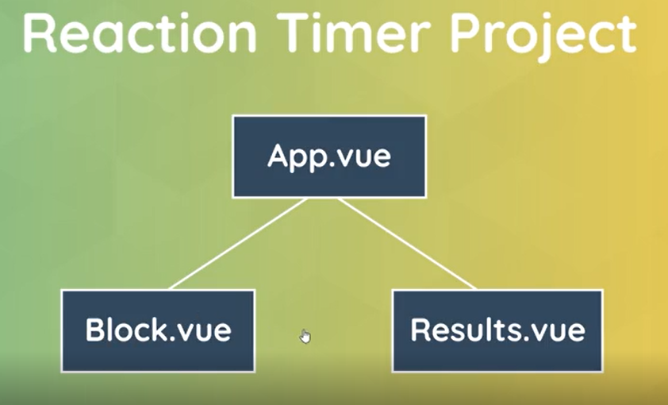

Make sure you are in the correct file path of where you want to create your projects in your terminal or command prompt.

To create a new Vue project type in the command **vue create *\*project name\****

Example: **vue create reaction-timer-game**

Select “Manually select features” option and press enter.

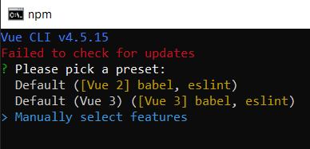

Deselect “Linter / Formatter” and leave “Choose Vue version” and “Babel” selected and press enter.

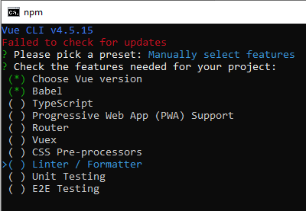

Select “3.x” and press enter.

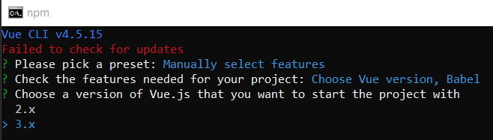

Select “In package.json” and press enter.

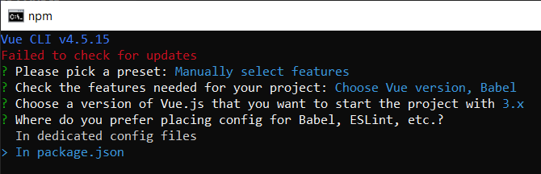

Type “n” and press enter

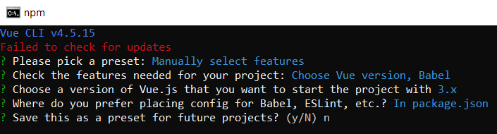

Change the directory by typing cd **modal-project** in the terminal or command prompt you are on.

Open the project using VS code, type **code .** in the terminal or command prompt in the directory of the project.

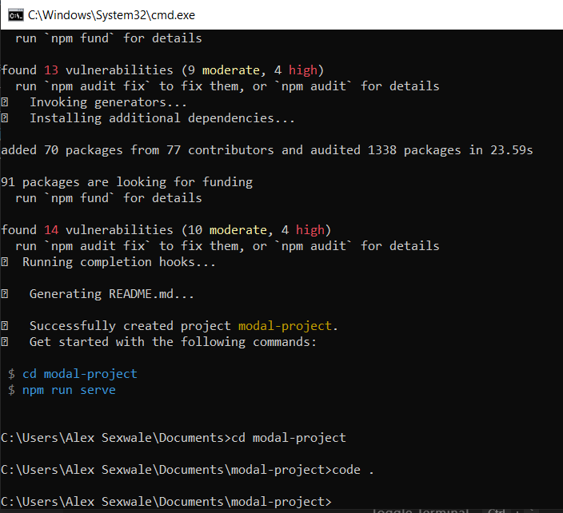

In order to run the project in the terminal or command prompt, make sure you are in the correct file path and type the command **npm run serve**. The project will open a new port, localhost://8080 which will allow you to view the website on your browser.

**Output:**

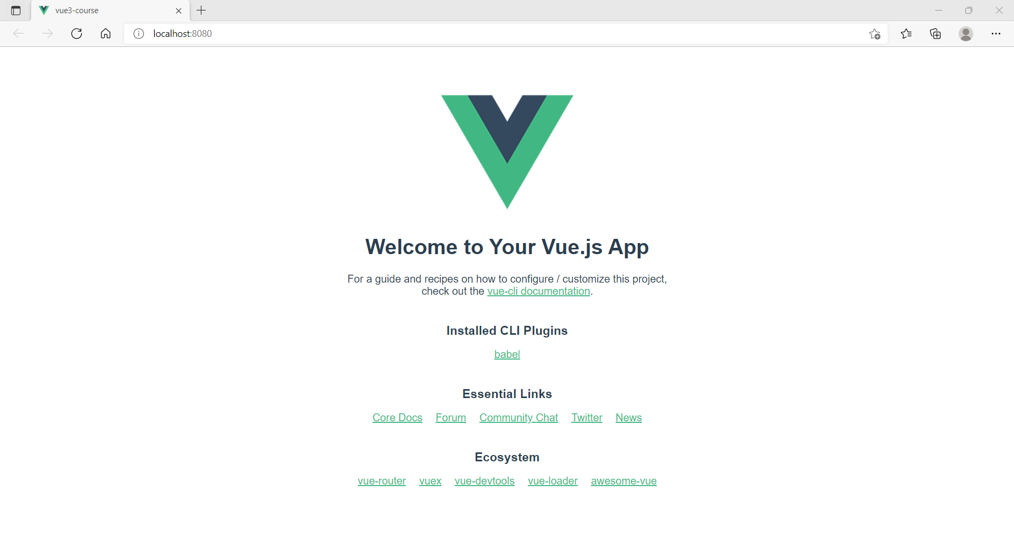

After creating the project, make sure to delete the HelloWorld.vue file in the components folder. Create two new components. Block.vue and Results.vue in the components folder.

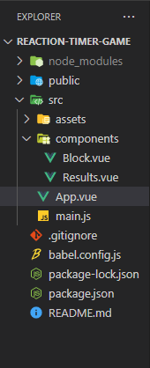

In the **App.vue** file, remove the HelloWorld component in the template tag and the script tag. Create an h1 tag in the template. Change the color style to #444.

Look at the example below (**between line 1 to 12**):

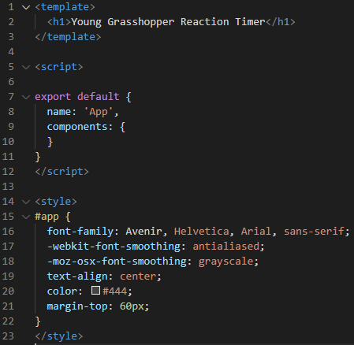

**You can view the code snippets from the** [**vue3-firebase-course**](https://github.com/younggrasshopperza/vue3-firebase-course) **repository under the Tutorial-20 branch**.